
Submitted by : Spogmai Jan
Roll no : 2430 -0081
Submitted to : mam yusra
Dsa lab 05:
TASK 01:
Write a function to display the Link List in reverse using an array.
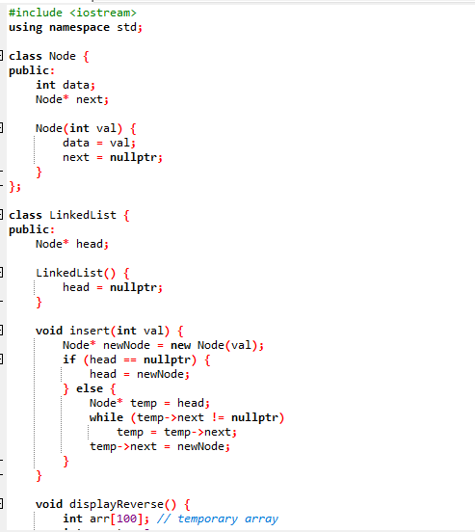
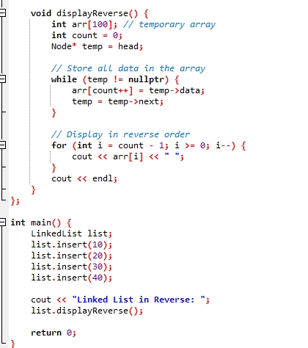

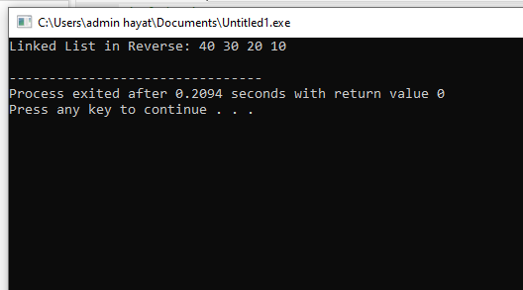
Task 02: Write a function to search a node by value and return a complete node in a singly linked list.
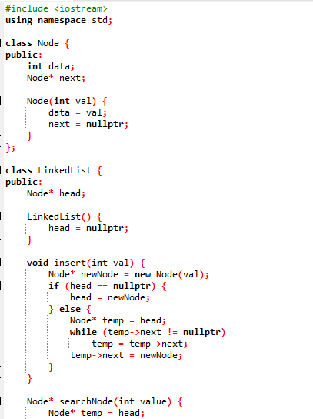
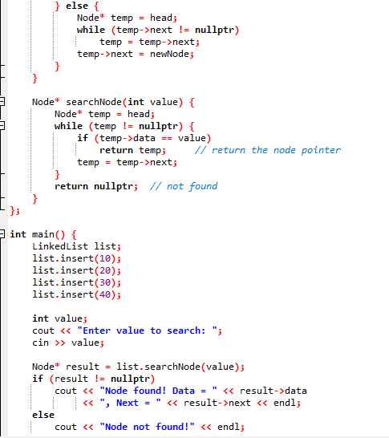
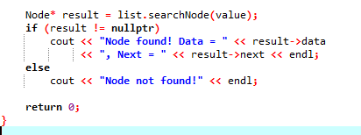
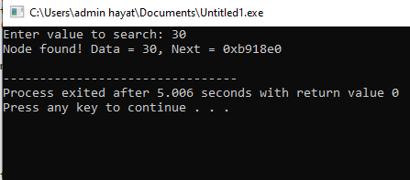
Task 03: Develop a straightforward student record management system employing a singly linked list
in C++. Define a Student class with the following attributes:
● ID (integer)
● Name (string)
● GPA (float)
● Pointer to the next node.
The system should enable users to:
● Add a student record (at the head, tail, and middle).
● Search for a student by ID.
● Display all student records
#include <iostream>
using namespace std;

class Student {
public:
int id;
string name;
float gpa;
Student* next;

Student(int i, string n, float g) {
id = i;
name = n;
gpa = g;
next = nullptr;
}
};

class StudentList {
private:
Student* head;

public:
StudentList() {
head = nullptr;
}

// Add at the beginning
void addAtHead(int id, string name, float gpa) {
Student* newStudent = new Student(id, name, gpa);
newStudent->next = head;
head = newStudent;
}

// Add at the end
void addAtTail(int id, string name, float gpa) {
Student* newStudent = new Student(id, name, gpa);
if (head == nullptr) {
head = newStudent;
return;
}
Student* temp = head;
while (temp->next != nullptr)
temp = temp->next;
temp->next = newStudent;
}

// Add in the middle (after a given ID)
void addAfterID(int targetID, int id, string name, float gpa) {
Student* temp = head;
while (temp != nullptr && temp->id != targetID)
temp = temp->next;

if (temp == nullptr) {
cout << "Target ID not found.\n";
return;
}

Student* newStudent = new Student(id, name, gpa);
newStudent->next = temp->next;
temp->next = newStudent;
}

// Search for a student by ID
Student* searchByID(int id) {
Student* temp = head;
while (temp != nullptr) {
if (temp->id == id)
return temp;
temp = temp->next;
}
return nullptr;
}

// Display all student records
void displayAll() {
if (head == nullptr) {
cout << "No student records found.\n";
return;
}
Student* temp = head;
cout << "\n--- Student Records ---\n";
while (temp != nullptr) {
cout << "ID: " << temp->id
<< ", Name: " << temp->name
<< ", GPA: " << temp->gpa << endl;
temp = temp->next;
}
}
};

int main() {
StudentList list;
int choice;

do {
cout << "\n1. Add Student at Head";
cout << "\n2. Add Student at Tail";
cout << "\n3. Add Student in Middle (after given ID)";
cout << "\n4. Search Student by ID";
cout << "\n5. Display All Students";
cout << "\n6. Exit";
cout << "\nEnter your choice: ";
cin >> choice;

int id, targetID;
string name;
float gpa;

switch (choice) {
case 1:
cout << "Enter ID, Name, GPA: ";
cin >> id >> name >> gpa;
list.addAtHead(id, name, gpa);
break;

case 2:
cout << "Enter ID, Name, GPA: ";
cin >> id >> name >> gpa;
list.addAtTail(id, name, gpa);
break;

case 3:
cout << "Enter target ID to insert after: ";
cin >> targetID;
cout << "Enter new student's ID, Name, GPA: ";
cin >> id >> name >> gpa;
list.addAfterID(targetID, id, name, gpa);
break;

case 4:
cout << "Enter ID to search: ";
cin >> id;
{
Student* s = list.searchByID(id);
if (s != nullptr)
cout << "Found → ID: " << s->id << ", Name: " << s->name << ", GPA: " << s->gpa << endl;
else
cout << "Student not found.\n";
}
break;

case 5:
list.displayAll();
break;

case 6:
cout << "Exiting...\n";
break;

default:
cout << "Invalid choice!\n";
}

} while (choice != 6);

return 0;
}
.



